Project Design Phase 2

Data Flow Diagram & User Stories

|  |  |  |
| --- | --- | --- |
| Date | 29 OCT 2022 | |
| Team ID | PNT2022TMID17615 |  |
| Project Name | Inventory Management System for Retailers | |
| Maximum Marks | 4 Marks | |

**Data Flow Diagram**

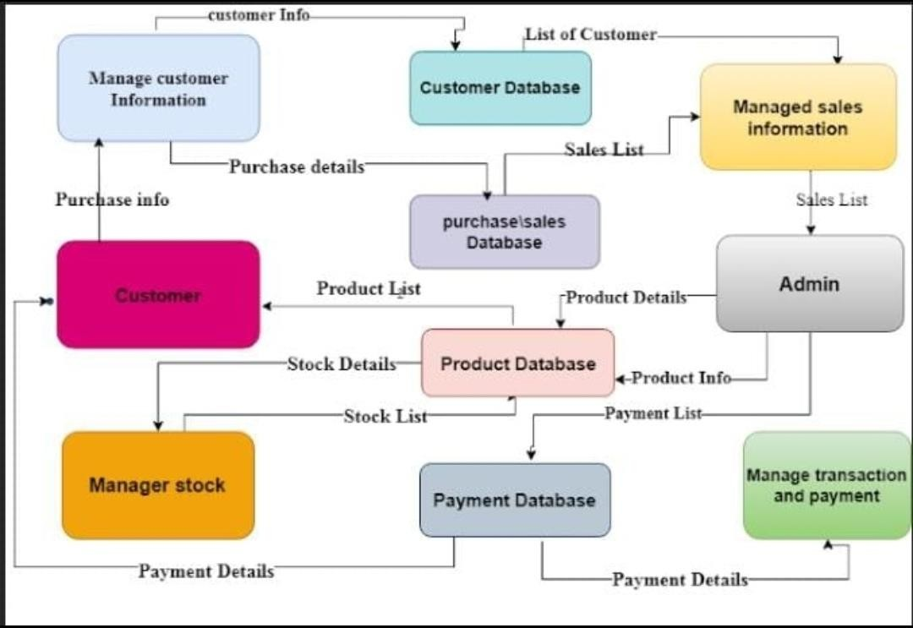

|  |  |  |  |  |  |  |
| --- | --- | --- | --- | --- | --- | --- |
| **User Type** | **Functional**  **Requirement (Epic)** | **User Story Number** | **User Story / Task** | **Acceptance criteria** | **Priority** | **Release** |
| Retailer (Web | Registration | USN-1 | As a user, I can register for the application by | I can access my account / | High | Sprint-1 |
| user) |  |  | entering my email, password, and confirming | dashboard |  |  |
|  |  |  | my password. |  |  |  |
|  |  | USN-2 | As a user, I will receive confirmation email | I can receive confirmation | High | Sprint-1 |
|  |  | once I have registered for the application | email & click confirm |  |  |
|  |  | USN-3 | As a user, I can register for the application | I can register & access | Low | Sprint-1 |
|  |  | through Gmail | dashboard with Gmail |  |  |
|  |  |  | Login |  |  |
|  | Login | USN-4 | As a user, I can log into the application by | I can log into the | Medium | Sprint-1 |
|  |  |  | entering email & password | application by entering |  |  |
|  |  |  |  | email and password |  |  |
|  | Dashboard | USN-5 | As a user, I can login into my application | I can access my | High | Sprint-1 |
|  |  |  |  | dashboard |  |  |
|  | Add new items | USN-6 | As a user, I can add new items to the | I can add new items to the | Medium | Sprint-2 |
|  |  |  | inventory along with the quantity bought | inventory |  |  |
|  | Search | USN-7 | As a user, I can search for a particular item for | I can find an item with item | High | Sprint-2 |
|  |  |  | its availability | id or name |  |  |
|  | Customer |  | As a user, I add a new customer / manage | I can add/view a customer | Low | Sprint-2 |
|  |  | their details before performing a sale |  |  |  |
|  | Sale | USN-8 | As a user, I can perform sale for a customer | I can add items to the | High | Sprint-2 |
|  |  |  | by entering the items and the quantity bought | customer list and sum up |  |  |
|  |  |  | by him | each value to calculate |  |  |
|  |  |  |  | total sale value |  |  |
|  | Visualizations | USN-9 | As a user, I can view the list of items along with the quantity bought in a particular time  period | I can view the items that were ordered the most  and the least | Low | Sprint-3 |
| Customer Care Executive | Feedback | USN-10 | As a user, I can record the feedbacks from different customers about the products and services | User friendly customer support | High | Sprint-3 |
| Administrator | Responsibility | USN-11 | As an administrator, I can only add and maintain users to this application | I can add and maintain users | High | Sprint-1 |